Yr 12 General Integrated Science
TASK 7 – Materials used in safety designs in vehicles

Millions of individuals drive every day to go to work, visit their family and friends or go on holiday. Due to weather conditions, or driver alertness, sometimes car accidents take place. To save lives on the road, car companies implemented safety features in their cars to minimise the effect of car collisions on occupants.
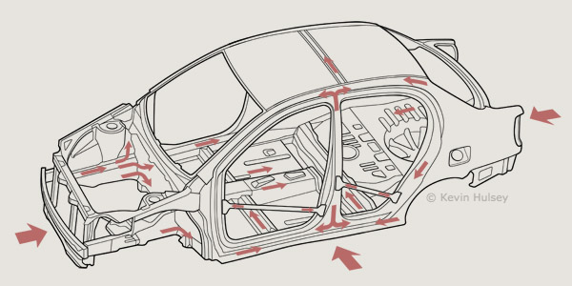
When making these safety features, scientists decide on the type of material to use for each safety feature. It has to match the purpose it has to serve in order for it to work properly and save lives.

Your task is to research the secondary safety design features, e.g. seatbelt, air bags and crumple zones, and include the following in your report:

- Define and describe the safety feature.
- Explain how it works.
- The type of material/s from which it is constructed and
- Explain the choice of material used and its suitability for the purpose for each safety feature.
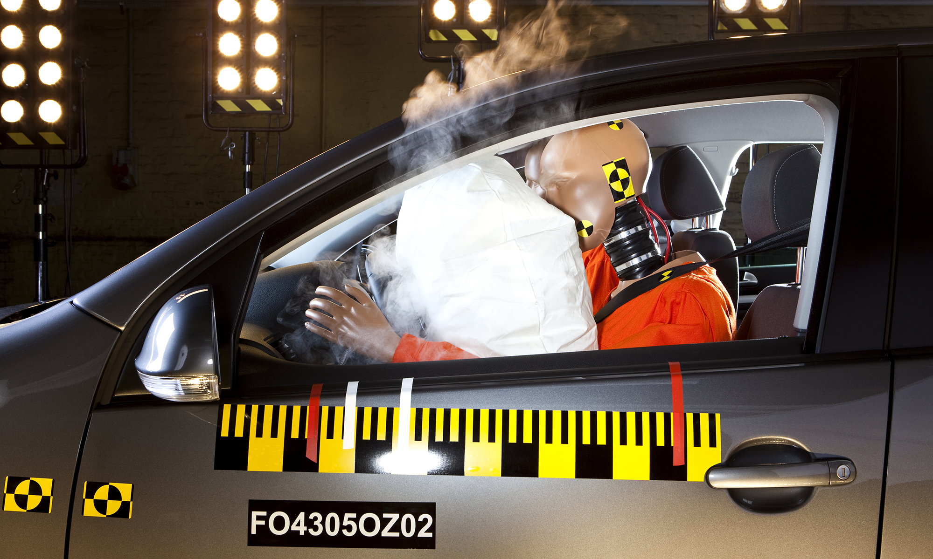

Due date: Friday Week 6.

